SMART SECURITY SYSTEM USING

IMAGE RECOGNITION

INTRODUCTION:

python:

* Python is one of the most popular programming languages used by developers today. Guido Van Rossum created it in 1991 and ever since its inception has been one of the most widely used languages along with C++, Java, etc.
* It is a [High-Level Programing](https://www.cuelogic.com/blog/10-best-iot-programming-languages) language and can be used for complicated scenarios.
* Python is an Interpreted language which in lay man’s terms means that it does not need to be compiled into machine language instruction before execution and can be used by the developer directly to run the program. This makes it comprehensive enough for the language to be interpreted by an emulator or a virtual machine on top of the native machine language which is what the hardware understands.

artificial intelligence:

* Artificial intelligence is the intelligence demonstrated by machines, in contrast to the intelligence displayed by humans.
* According to the father of Artificial Intelligence, John McCarthy, it is “The science and engineering of making intelligent machines, especially intelligent computer programs”.
* As we know that AI pursues creating the machines as intelligent as human beings. There are numerous reasons for us to study AI.

### 1. AI can learn through data

### 2. AI can teach itself

### 3. AI can respond in real time

### 4. AI can respond in real time

### 5. AI can organize data to get most out of it

### 6. Understanding Intelligence

AI and python :

* Python has Prebuilt Libraries like Numpy for scientific computation, Scipy for advanced computing and Pybrain for machine learning (Python Machine Learning) making it one of the best languages For AI.
* Python developers around the world provide comprehensive support and assistance via forums and tutorials making the job of the coder easier than any other popular languages.
* Python is platform Independent and is hence one of the most flexible and popular choiceS for use across different platforms and technologies with the least tweaks in basic coding.
* Python is the most flexible of all others with options to choose between OOPs approach and scripting. You can also use IDE itself to check for most codes and is a boon for developers struggling with different algorithms.

Objectives of Research

### Difference between face verification and face recognition

Face verification technique is used to verify whether the input image is of the legitimate claimant(1 to 1 mapping). However, face recognition is used to recognize whether the input face image is from a set of an authorized group of individuals (1 to M mapping).

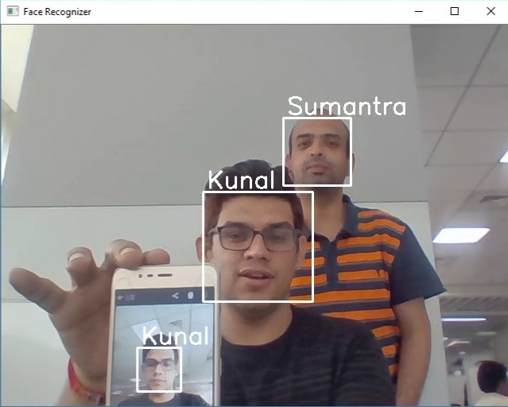

Basic face recognizer using a pre-trained model

### Difference between face recognition and face spoofing detection

As shown in the above screen grab of the application, it only demonstrated basic face recognition, which can recognize the faces from digital photos, videos, and 3 D modeled faces also. Preventing attackers from using non-live faces for accessing the privileged system is called **face spoofing detection**, which is out of the scope of this application. Face spoofing detection can be achieved by various techniques such as **liveness detection, contextual information, user interaction, and texture analysis.**

Training a new deep convolution neural network (CNN) for face recognition is extremely difficult because of the complexity of the data set and the enormous requirement of computing power. Hence, I will be creating a basic facial recognition application using a pre-trained model which is open source.

Problem Statement

Problem:

SMART SECURITY SYSTEM USINGIMAGE RECOGNITION

* Web-based technology has improved drastically in the past decade.  
   As a result, security technology has become a major help to protect our daily life
* Modernization is leading to a remarkable increase number of crimes, especially robbery.
* It is necessary to have a robust system which can distinguish between people and respond differently based on their privileges.  
  A number of methods are available for detecting and recognizing faces with various levels of complexities.
* Face recognition facilitates automation and security.   
  It has already been used in many applications including ID issuance, law enforcement, border control, and many other commercial products.

**Solution**

* There are lots of CNN architectures available for free and unrestricted use that can achieve reasonable performance on hard visual recognition tasks.
* How Do Convolutional Neural Networks Work?  
  There are four layered concepts we should understand in Convolutional Neural Networks:
* Convolution: Convolution is performed on an image to identify certain features in an image. Convolution helps in blurring, sharpening, edge detection, noise reduction and more on an image that can help the machine to learn specific characteristics

of an image.

* Pooling: A convoluted image can be too large and therefore needs to be reduced.   
  Pooling is mainly done to reduce the image without losing features or patterns.
* Flattening: Flattening transforms a two-dimensional matrix of features into a vector of features that can be fed into  
   a neural network or classifier.
* Full-Connection: Full connection simply refers to the process of feeding the flattened image into a neural network.

Review of literature

Approach of face recognition aims to detect faces in still image and sequence image from video have many method such as local, global, and hybrid approach. The main problem of face recognition are intensity, illumination, pose, difficult to controlling and large occlusion. In 3D capture creates larger data files per subject which applies significant storage requirements, slow processing, most new devices can be capture in 3D. This is the problem for our future work that want to solving and create accuracy gain for widely accept in 3D face recognition system.

**Data Collection**

The data has been gathered from different articles ,websites by different authors

some of them are:-

* <https://link.medium.com/qNjA4AdcSW>
* <https://searchenterpriseai.techtarget.com/definition/image-recognition>
* <https://www.marutitech.com/working-image-recognition/>

|  |  |  |
| --- | --- | --- |
| |  | | --- | | https://mail.google.com/mail/u/0/images/cleardot.gif  https://mail.google.com/mail/u/0/images/cleardot.gif | |  * <https://www.researchgate.net/publication/329884419_A_Smart_Security_System_with_Face_Recognition> * <https://www.tutorialspoint.com/python/tk_colors.htm> * <https://www.instructables.com/id/Face-Detectionrecognition/> |  |

Methodology

A facial recognition methodology is a way to automatically verify person by matching his digital image with the database of images.  
Nowadays the security of person, information or assets is becoming more difficult and important.

**Exploratory Data Analysis:**

**Figures**

For example, in the below image if you want to extract cat from the background you will notice a significant variation in RGB pixel values.

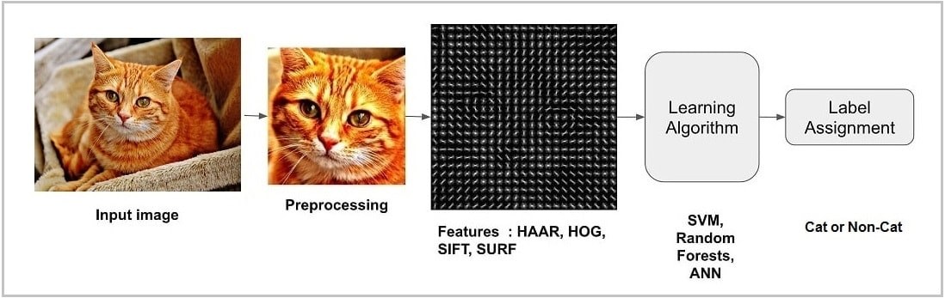

**Image -1**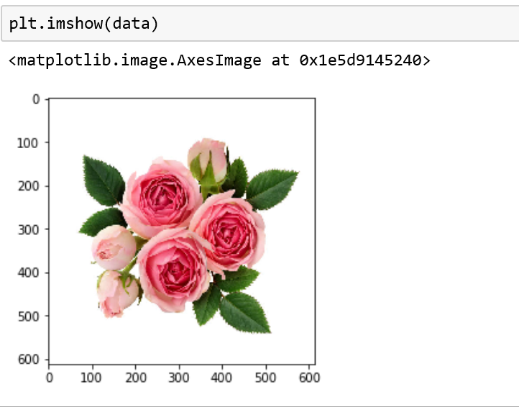

**Image -2**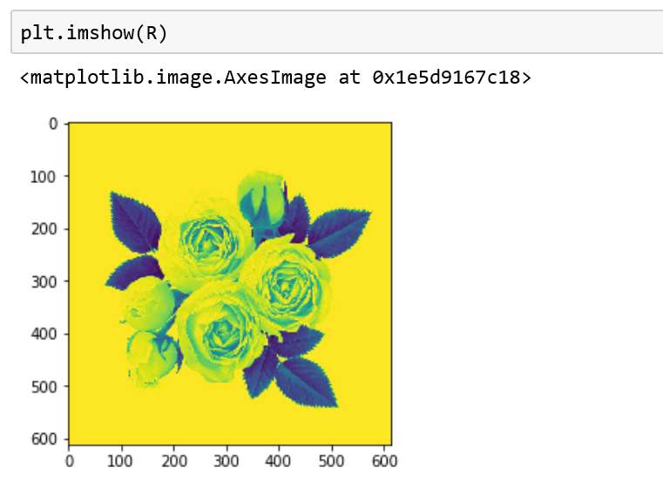

**Tables:-**

|  |  |  |
| --- | --- | --- |
| Data Division | Authorized | unauthorized |
| Training | 320 | 190 |
| Testing | 100 | 190 |
| Total no of images | 420 | 380 |

DATA MODELING:

* Currently OpenCV supports a wide variety of programming languages like C++, Python, Java etc and is available on different platforms including Windows, Linux, OS X, Android, iOS etc. Also, interfaces based on CUDA and OpenCL are also under active development for high-speed GPU operations.
* OpenCV-Python is the Python API of OpenCV. It combines the best qualities of OpenCV C++ API and Python language.
* We have also used the face recognition ,haarcasacade frontal face and haarcascade eye code to implement our use case.
* In deep learning, a convolutional neural network (CNN, or ConvNet) is a class of deep neural networks, most commonly applied to analyzing visual imagery.
* They are also known as shift invariant or space invariant artificial neural networks (SIANN), based on their shared-weights architecture and translation invariance characteristics.
* CNNs use relatively little pre-processing compared to other image classification algorithms.
* This independence from prior knowledge and human effort in feature design is a major advantage.
* A convolutional neural network consists of an input and an output layer, as well as multiple hidden layers.
* The hidden layers of a CNN typically consist of convolutional layers, RELU layer i.e. activation function, pooling layers, fully connected layers and normalization layers.

Findings

### A lot of people and organizations use facial recognition — and in a lot of different places. Here’s a sampling:

### U.S. government at airports. Facial recognition systems can monitor people coming and going in airports. The Department of Homeland Security has used the technology to identify people who have overstayed their visas or may be under criminal investigation. Customs officials at Washington Dulles International Airport made their first arrest using facial recognition in August 2018, catching an impostor trying to enter the country.

### Mobile phone makers in products. Apple first used facial recognition to unlock its iPhone X, and continues with the iPhone XS. Face ID authenticates — it makes sure you’re you when you access your phone. Apple says the chance of a random face unlocking your phone is about one in 1 million.

### Colleges in the classroom. Facial recognition software can, in essence, take roll. If you decide to cut class, your professor could know. Don’t even think of sending your brainy roommate to take your test.

### Social media companies on websites. Facebook uses an algorithm to spot faces when you upload a photo to its platform. The social media company asks if you want to tag people in your photos. If you say yes, it creates a link to their profiles. Facebook can recognize faces with 98 percent accuracy.

### Businesses at entrances and restricted areas. Some companies have traded in security badges for facial recognition systems. Beyond security, it could be one way to get some face time with the boss.

### Religious groups at places of worship. Churches have used facial recognition to scan their congregations to see who’s present. It’s a good way to track regulars and not-so-regulars, as well as to help tailor donation requests.

### Retailers in stores. Retailers can combine surveillance cameras and facial recognition to scan the faces of shoppers. One goal: identifying suspicious characters and potential shoplifters.

### Airlines at departure gates. You might be accustomed to having an agent scan your boarding pass at the gate to board your flight. At least one airline scans your face.

### Marketers and advertisers in campaigns. Marketers often consider things like gender, age, and ethnicity when targeting groups for a product or idea. Facial recognition can be used to define those audiences even at something like a concert.

Suggestions:

### Will hackers really want to steal your face? If your facial data can be used to commit fraud or turn a profit, the answer is yes. Add that to the list of cyber safety risks.

### A holistic cyber safety package is worth considering for help protecting your online privacy and security. For instance, [Norton Security](https://us.norton.com/plans) is designed to help protect your computer, laptop, and mobile devices against viruses, ransomware, and cybercriminals.

### Still, facial recognition represents a challenge to your privacy.

Conclusion

In reviewing, we found many approach can be used for face recognition that each method have different advantage and disadvantage such as local, global, and hybrid method. There are have 2 type of image for face recognition technique: still image and video image (still image sequence). However, we found some problems in face recognition system such as:

(1) pose problem : due to can not control face image for capturing and have many pose variation will be change every time.

(2) illumination problem : due to source image have light condition or different lighting and viewing variations.

(3) environment problem : due to in fact, motion and expression can not controlling that is natural image.

(4) 3D problem : due to in 3D image must be used more storage, many variable, low speed, and lack of face database testing.

we have found in our research that in future they may propose a novel method for face recognition by hybrid approach combines 3D face and face expression. (eyes, nose, and mouth are location feature for extraction). We found 3D recognition more accurate than 2D recognition, 3D capture creates larger data files per subject which applies significant storage requirements, slow processing, most new devices can be capture in 3D, and can not control environment from the real world.

|  |  |
| --- | --- |
|  |  |